CSE 581

**Lab 3: Selects with Joins**

1. List all orders and their corresponding order details.

SELECT *

FROM Orders o LEFT OUTER JOIN [Order Details] od

ON o.OrderID = od.OrderID;

1. List all orders (OrderID) and all customers (Company Name), matching records appropriately.

SELECT o.OrderID, c.CompanyName

FROM Orders o FULL OUTER JOIN Customers c

ON o.CustomerID = c.CustomerID;

1. List orders (OrderID) and corresponding customers (Company Name), only where the records match up.

SELECT o.OrderID, c.CompanyName

FROM Orders o INNER JOIN Customers c

ON o.CustomerID = c.CustomerID;

1. List all orders (OrderID) and matching customers (Company Name).

SELECT o.OrderID, c.CompanyName

FROM Orders o LEFT OUTER JOIN Customers c

ON o.CustomerID = c.CustomerID;

1. List matching orders (OrderID) and all customers (Company Name).

SELECT o.OrderID, c.CompanyName

FROM Orders o RIGHT OUTER JOIN Customers c

ON o.CustomerID = c.CustomerID;

1.

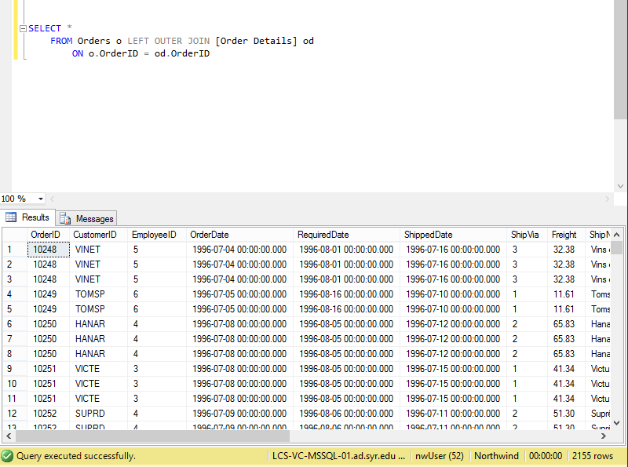

2.

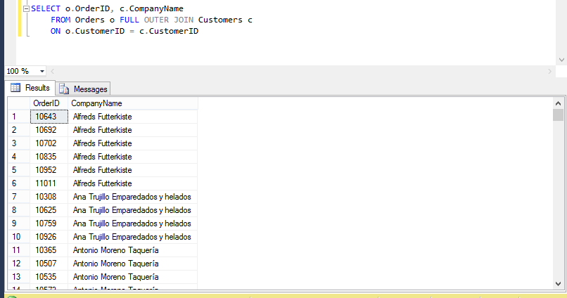

3.

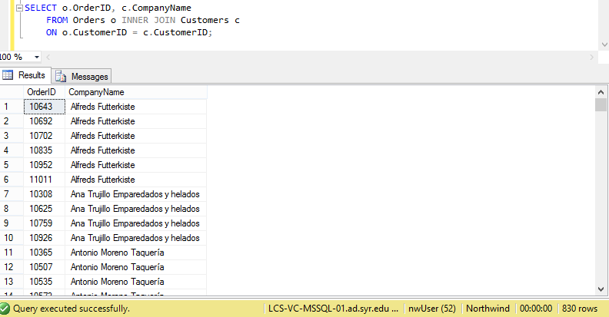

4.

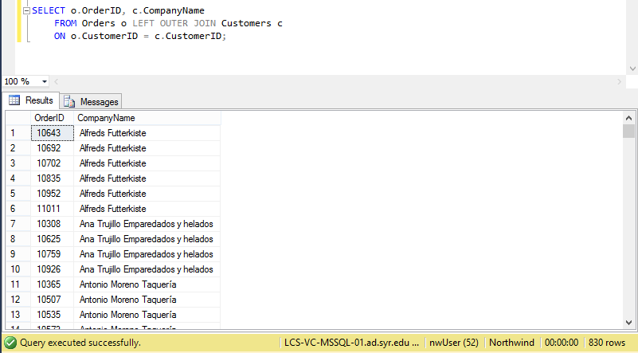

5.

